SQL SERVER - TASKS

TASK – 1

USE TRAINING
CREATE TABLE Trainees (
Trainee_ID INT PRIMARY KEY,
FIRST_NAME CHAR(25),
LAST_NAME CHAR(25),
SALARY INT,
JOINING_DATE DATETIME,
DEPARTMENT CHAR(25)
);

Insert 20 sets of records for the above created table based on the requirements in the below queries and perform the following queries.
1. Retrieve all FIRST_NAME STARTING WITH J-T and should differentiate between Uppercase and lowercase.
2. Retrieve all SALARY BETWEEN 20000 TO 50000
3. Retrieve all FIRST_NAME ending with i
4. Retrieve all salary without duplications
5. Retrieve all records whose department is Developer and Designer
6. Retrieve all Trainee_ID less than 5
7. Limit the records by retrieving the 6 to 15 records
8. Retrieve the top 5 records with Ties
9. Retrieve the records in descending order based on department column.
10. Retrieve all last_name with 3rd character as 'a.'

TASK – 2
USE TRAINING
Perform the following queries:
1. Create a table with primary key, unique key, check and default constraints.
2. Rename a table, database & schema.
3. Create a table with the following fields:
a. id as identity column, name, salary, increment, computed column as Revised salary(salary + increment)
b. Retrieve all the records whose salary is >20000 and move them into a new table using (SELECT INTO)

TASK – 3

USE TRAINING
the working of Primary and Foreign key for the tables in the attached image. Show

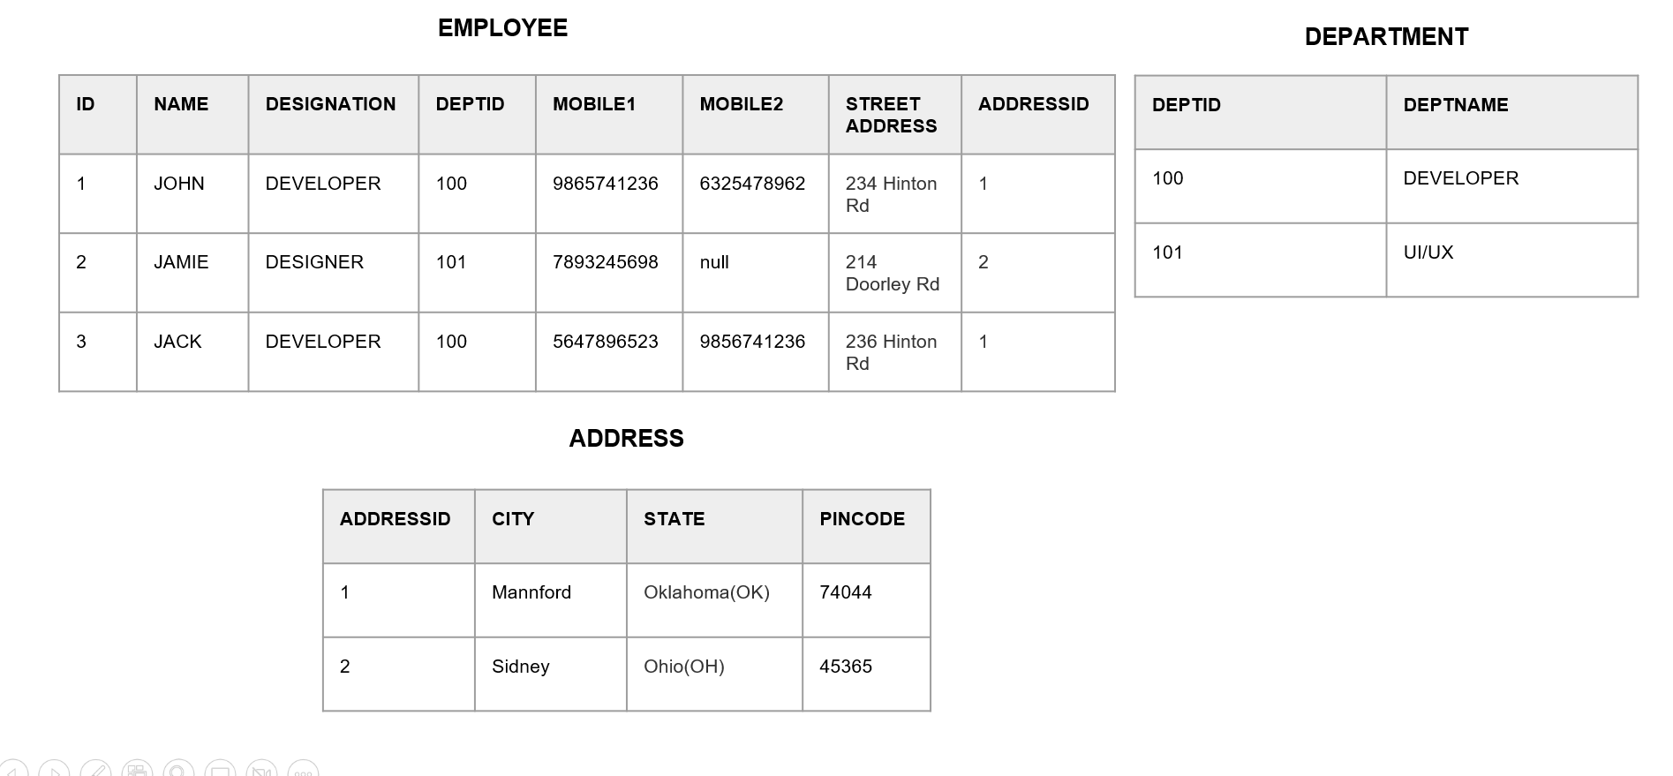

TASK – 4

USE TRAINING
CREATE TABLE Worker (
WORKER_ID INT NOT NULL PRIMARY KEY,
FIRST_NAME CHAR(25),
LAST_NAME CHAR(25),
SALARY INT,
JOINING_DATE DATETIME,
DEPARTMENT CHAR(25)
);

INSERT INTO Worker
(WORKER_ID, FIRST_NAME, LAST_NAME, SALARY,
JOINING_DATE, DEPARTMENT) VALUES
(002, 'Niharika', 'Verma', 80000, '2000-02-02', 'Admin'),
(003, 'Vishal', 'Singhal', 300000, '2000-02-02', 'HR'),
(004, 'Amitabh', 'Singh', 500000, '2000-02-02', 'Admin'),
(005, 'Vivek', 'Bhati', 500000, '2000-02-02', 'Admin'),
(006, 'Vipul', 'Diwan', 200000, '2000-02-02', 'Account'),
(007, 'Satish', 'Kumar', 75000, '2000-02-02', 'Account'),
(008, 'Geetika', 'Chauhan', 90000, '2000-02-02', 'Admin');

CREATE TABLE Bonus (
WORKER_REF_ID INT, BONUS_AMOUNT INT, BONUS_DATE DATETIME, FOREIGN KEY (WORKER_REF_ID)
REFERENCES Worker(WORKER_ID)
ON DELETE CASCADE);

INSERT INTO Bonus
(WORKER_REF_ID, BONUS_AMOUNT, BONUS_DATE) VALUES
(001, 5000, '2016-02-02'),
(002, 3000, '2016-06-01'),
(003, 4000, '2016-02-02'),
(001, 4500, '2016-02-02'),
(002, 3500, '2016-06-01');

CREATE TABLE Title (
WORKER_REF_ID INT, WORKER_TITLE CHAR(25),
AFFECTED_FROM DATETIME, FOREIGN KEY (WORKER_REF_ID)
REFERENCES Worker(WORKER_ID) ON DELETE CASCADE
);
INSERT INTO Title
(WORKER_REF_ID, WORKER_TITLE, AFFECTED_FROM) VALUES
(001, 'Manager', '2016-02-20 00:00:00'),
(002, 'Executive', '2016-06-11 00:00:00'),
(008, 'Executive', '2016-06-11 00:00:00'),
(005, 'Manager', '2016-06-11 00:00:00'),
(004, 'Asst. Manager', '2016-06-11 00:00:00'),
(007, 'Executive', '2016-06-11 00:00:00'),
(006, 'Lead', '2016-06-11 00:00:00'),
(003, 'Lead', '2016-06-11 00:00:00');

Q-1. Write an SQL query to fetch “FIRST_NAME” from Worker table using the alias name as <WORKER_NAME>.

Q-2. Write an SQL query to fetch “FIRST_NAME” from Worker table in upper case.

Q-3. Write an SQL query to fetch unique values of DEPARTMENT from Worker table.

Q-4. Write an SQL query to print the first three characters of FIRST_NAME from Worker table.

Q-5. Write an SQL query that fetches the unique values of DEPARTMENT from Worker table and prints its length.
Q-6. Write an SQL query to print the FIRST_NAME and LAST_NAME from Worker table into a single column COMPLETE_NAME. A space char should separate them.

Q-7. Write an SQL query to print details for Workers with the first name as “Vipul” and “Satish” from Worker table.

Q-8. Write an SQL query to print details of Workers with DEPARTMENT name as “Admin”.

Q-9. Write an SQL query to print details of the Workers whose FIRST_NAME ends with ‘a’.

Q-10. Write an SQL query to print details of the Workers whose FIRST_NAME contains ‘a’.

